80% Vaccination Uptake

Population-wise projections

Cervical Cancer Incidence
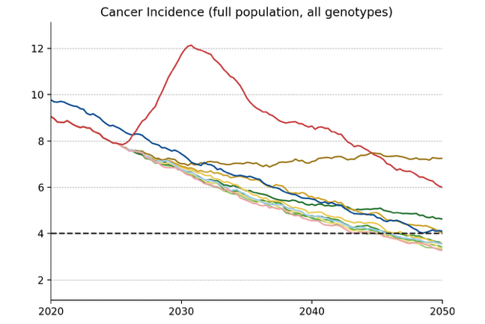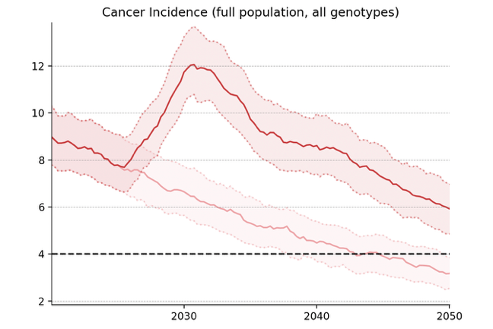
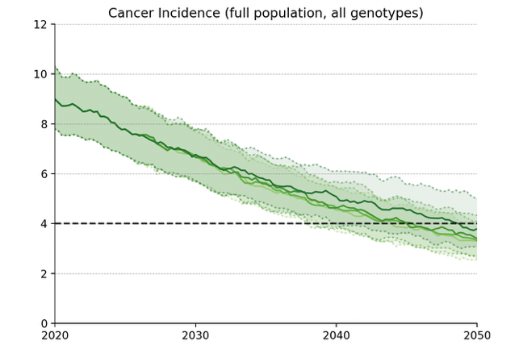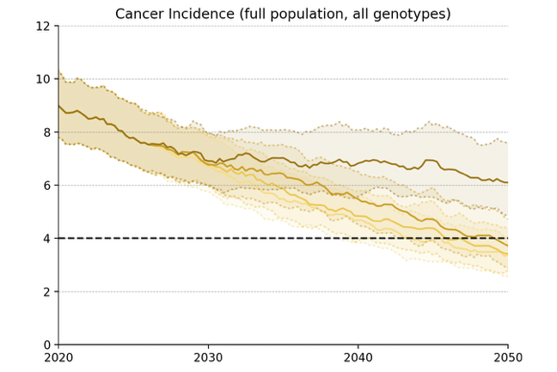
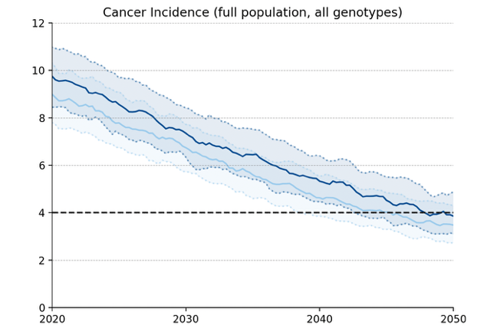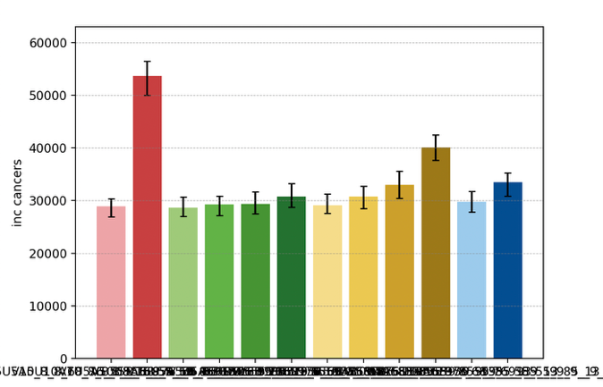
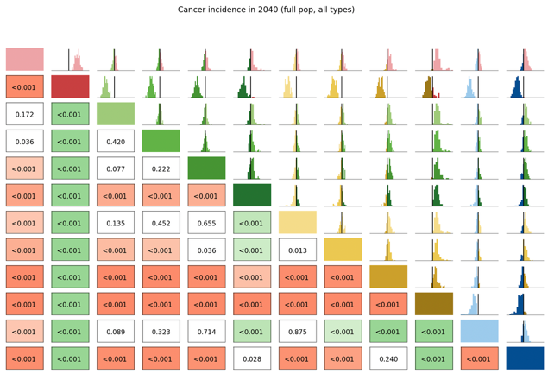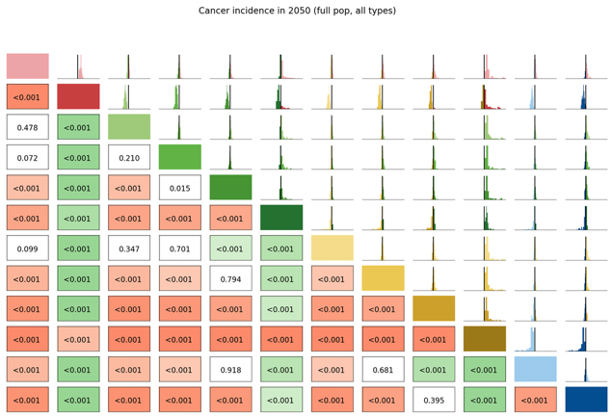

Long Term Undiagnosed Prevalence
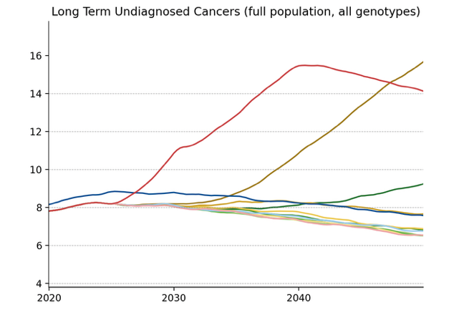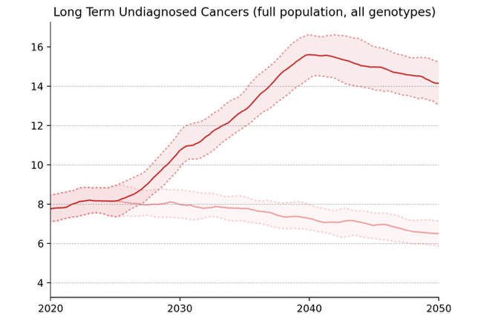
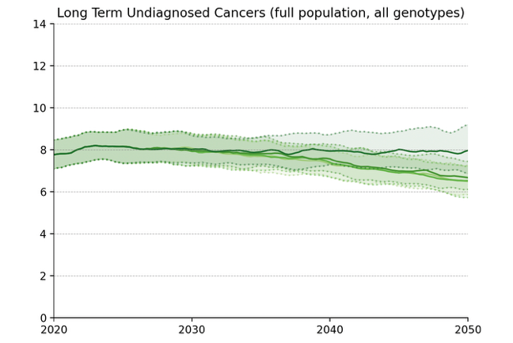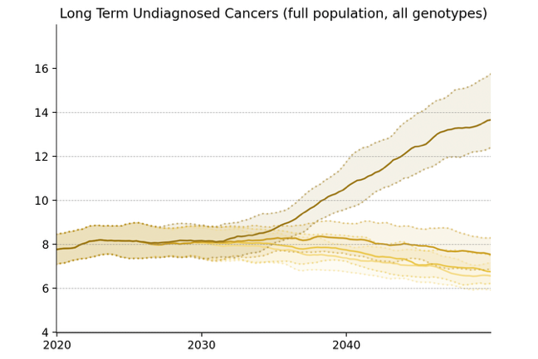
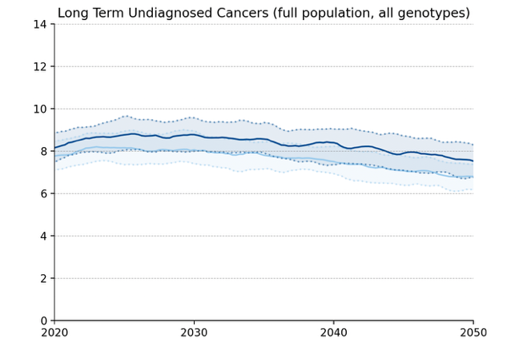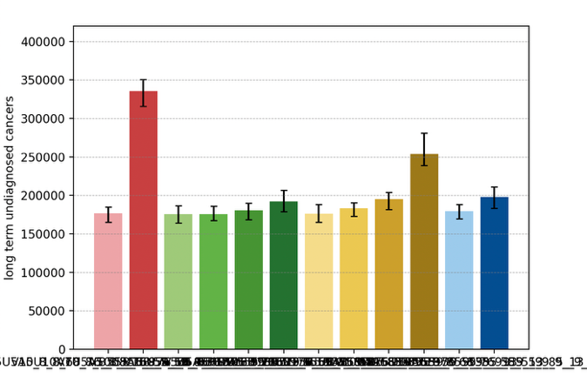
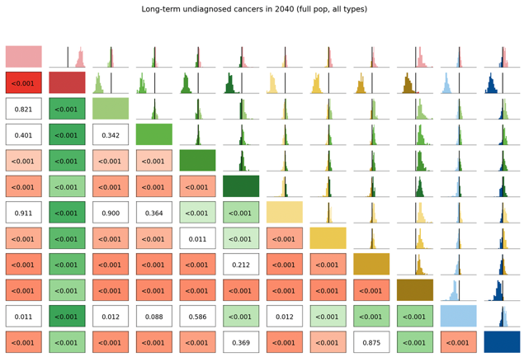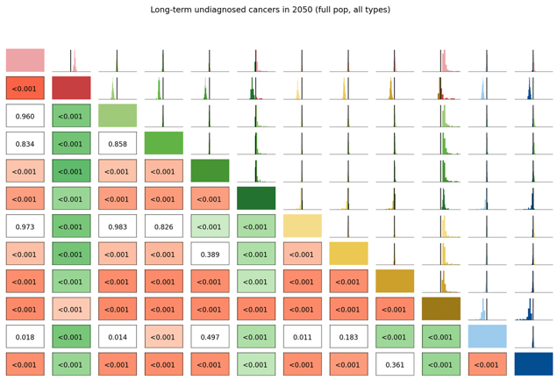

Number of Routine Screens
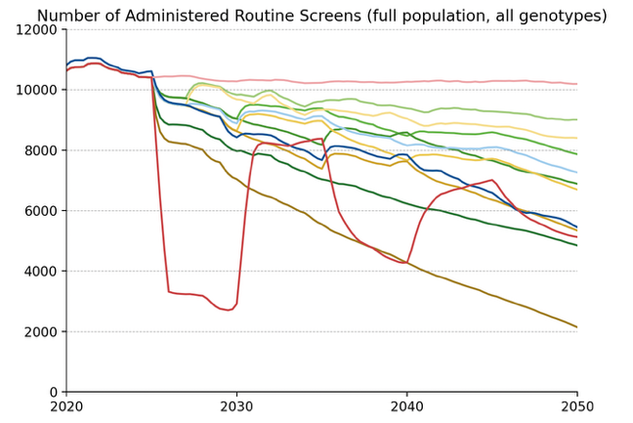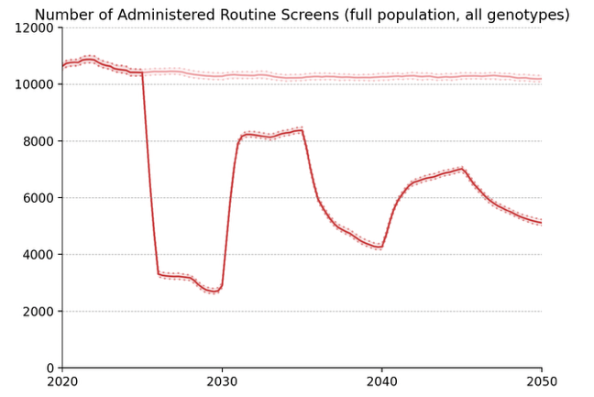
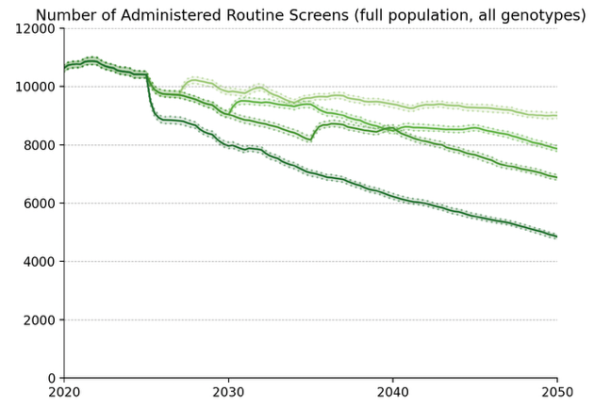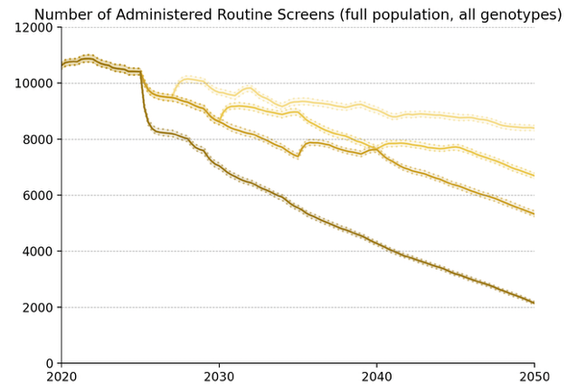
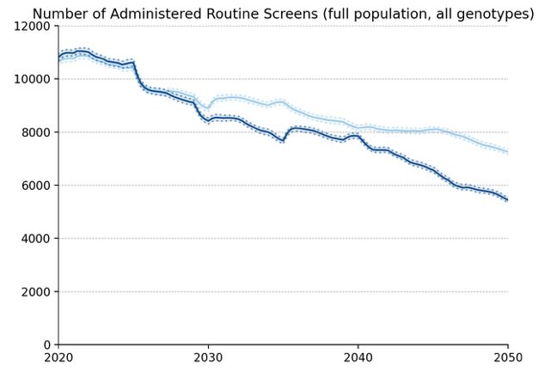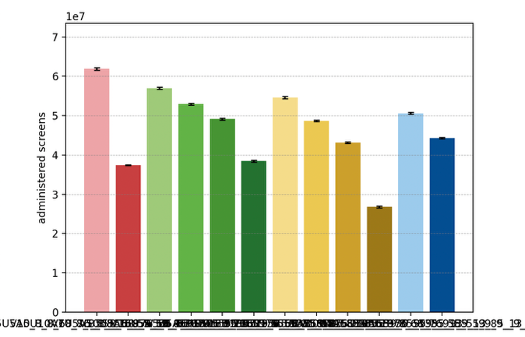

Average Number of Screens per Diagnosed Cancer, 2030-50
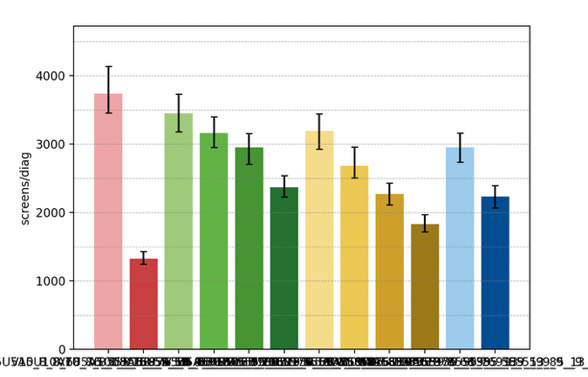

Elimination Probability Table
alg | Elimination Year: Median [LQ, UQ] (_8) | 2040.25 Elimination Probability (_8) | 2050.25 Elimination Probability (_8)
V5U5A5 | 2049 [2046, 2051] | 0.032 | 0.640
V7U5A5 | 2048 [2046, 2052] | 0.024 | 0.648
V10U5A5 | 2049 [2047, 2053] | 0.024 | 0.590
V15U5A5 | 2050 [2047, 2053] | 0.032 | 0.557
V_U5A5 | 2053 [2050, 2055] | 0.024 | 0.344
V7U7A5 | 2050 [2046, 2053] | 0.040 | 0.557
V10U10A5 | 2051 [2048, 2054] | 0.024 | 0.484
V15U15A5 | 2053 [2050, 2054] | 0.016 | 0.303
V_U_A5 | 2056 [2055, 2056] | 0.016 | 0.016
V10U7A5 | 2050 [2048, 2053] | 0.024 | 0.557
V15U10A5 | 2052 [2050, 2055] | 0.016 | 0.295
V10U10A10 | 2055 [2055, 2056] | 0.016 | 0.016
Maximum margin: 0.08873169135809261

Vaccinated Population projections

Cervical Cancer Incidence
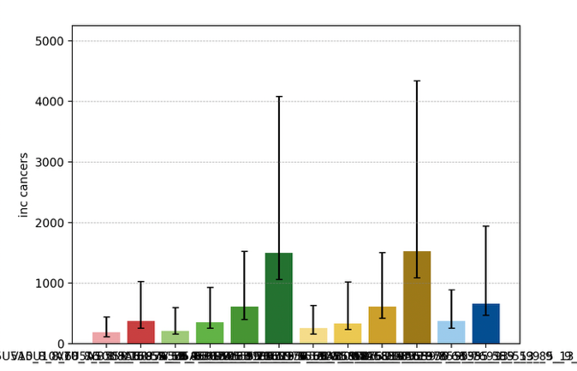
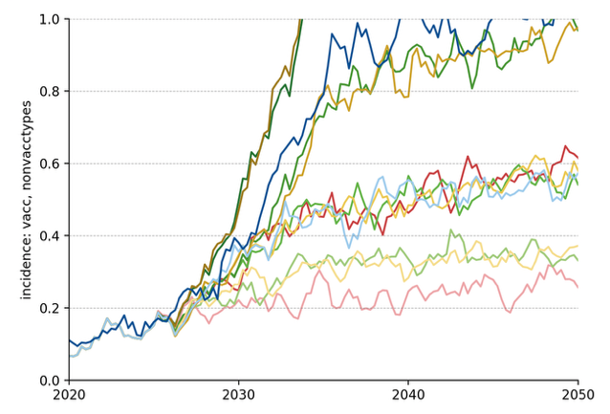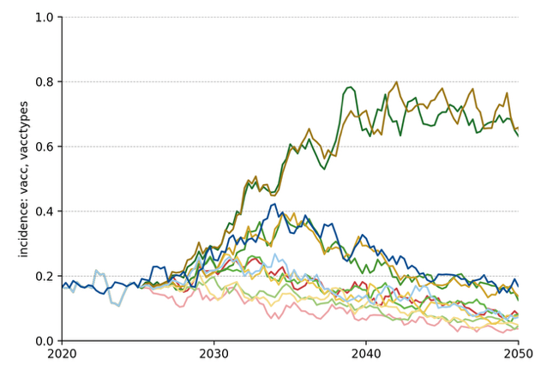
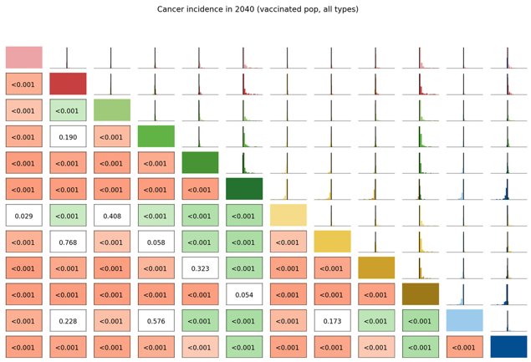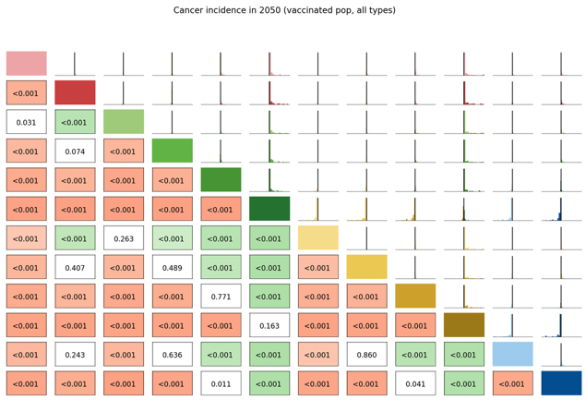

Long Term Undiagnosed Prevalence
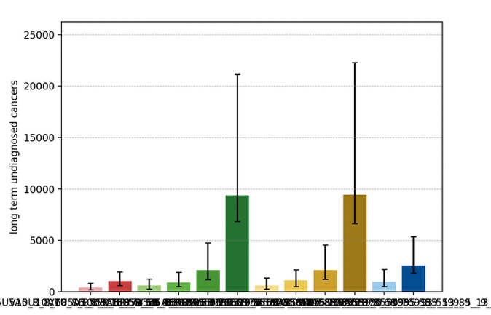
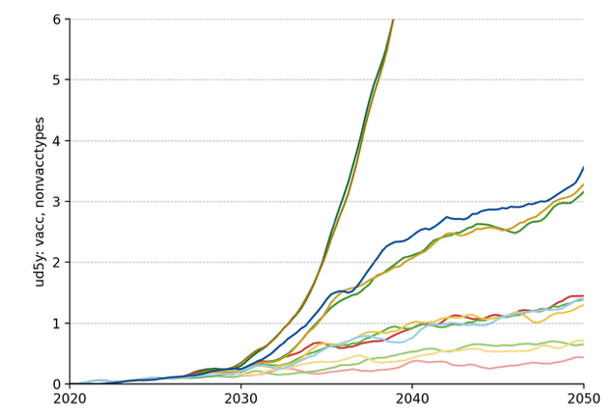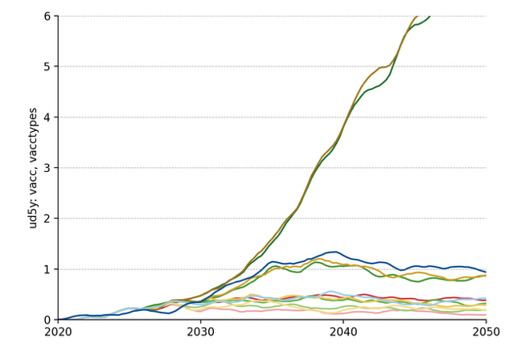

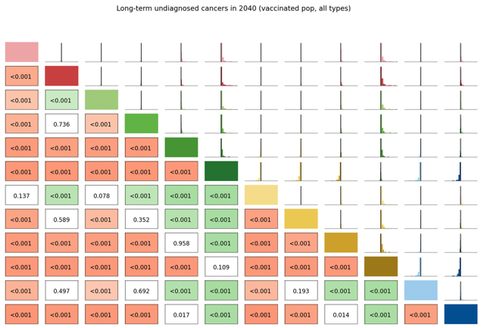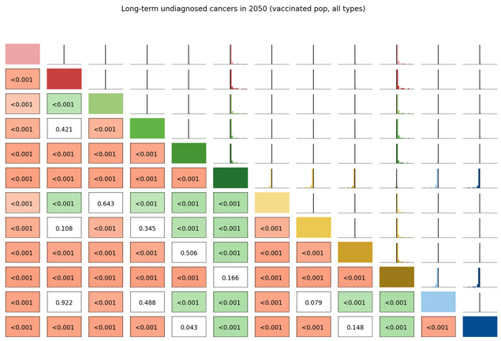

Number of Routine Screens
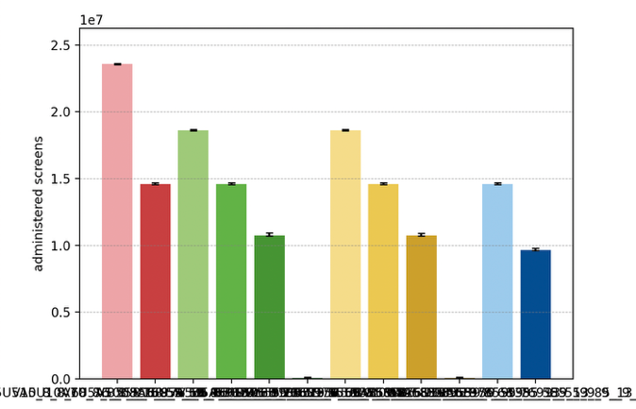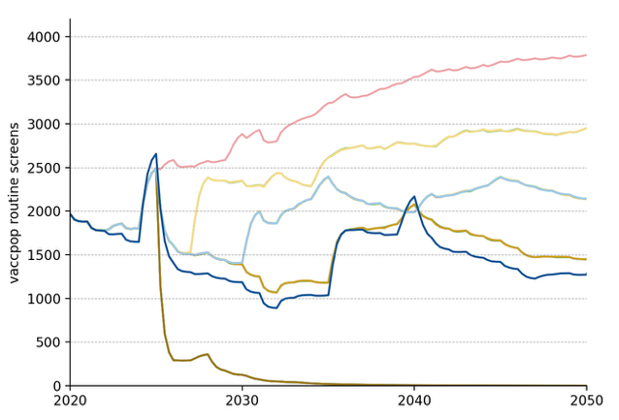

Average Number of Screens per Diagnosed Cancer, 2030-50
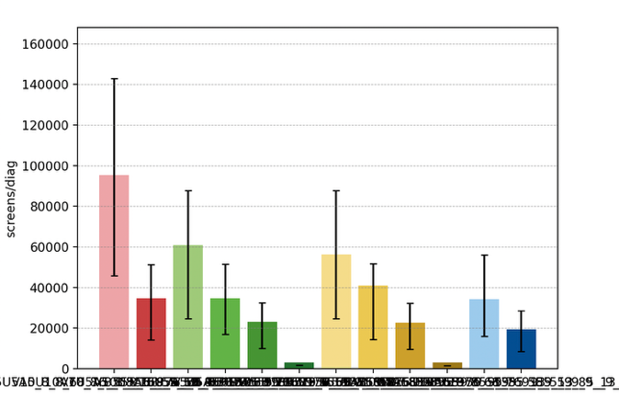

Elimination Probability Table
alg | Elimination Year: Median [LQ, UQ] (_8) | 2040.25 Elimination Probability (_8) | 2050.25 Elimination Probability (_8)
V5U5A5 | 2008 [2008, 2008] | 0.960 | 0.960
V7U5A5 | 2008 [2008, 2008] | 0.943 | 0.951
V10U5A5 | 2008 [2008, 2008] | 0.894 | 0.910
V15U5A5 | 2008 [2008, 2008] | 0.837 | 0.845
V_U5A5 | 2008 [2008, 2055] | 0.689 | 0.705
V7U7A5 | 2008 [2008, 2008] | 0.935 | 0.943
V10U10A5 | 2008 [2008, 2008] | 0.886 | 0.910
V15U15A5 | 2008 [2008, 2008] | 0.853 | 0.861
V_U_A5 | 2008 [2008, 2054] | 0.697 | 0.713
V10U7A5 | 2008 [2008, 2008] | 0.886 | 0.894
V15U10A5 | 2008 [2008, 2008] | 0.845 | 0.845
V10U10A10 | 2008 [2008, 2008] | 0.886 | 0.894
Maximum margin: 0.0819879677430051

Unvaccinated Vaccine Eligible Population projections

Cervical Cancer Incidence
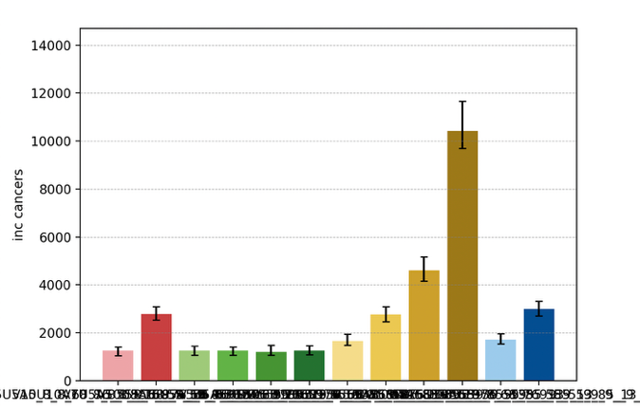
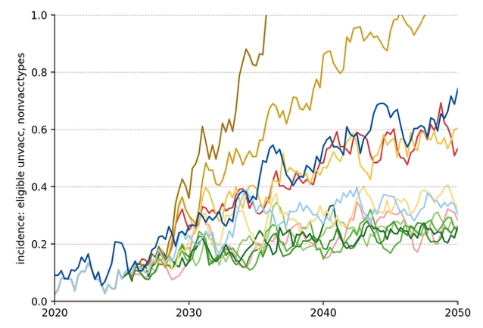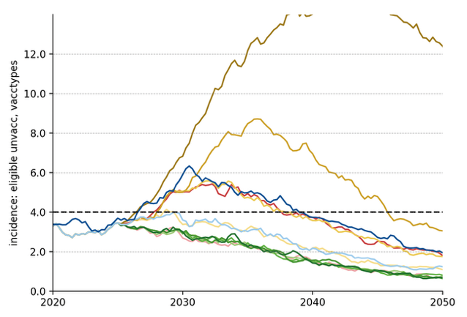

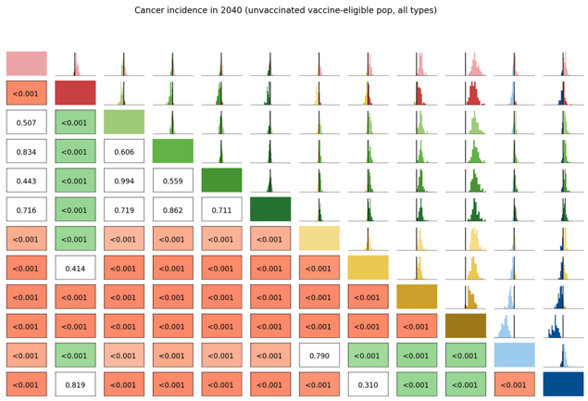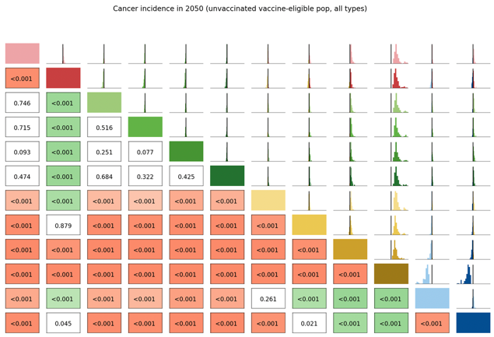

Long Term Undiagnosed Prevalence
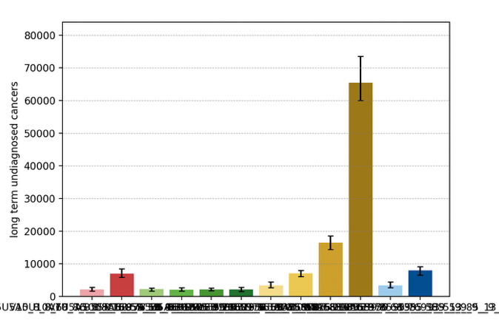

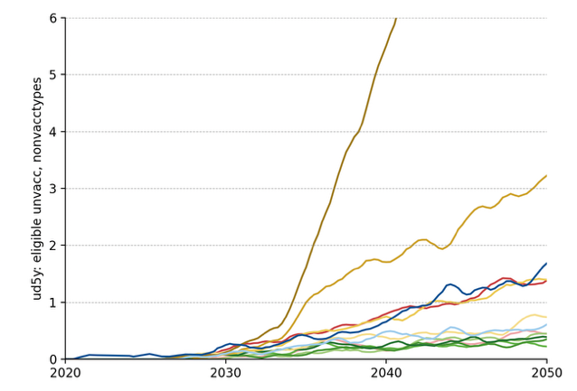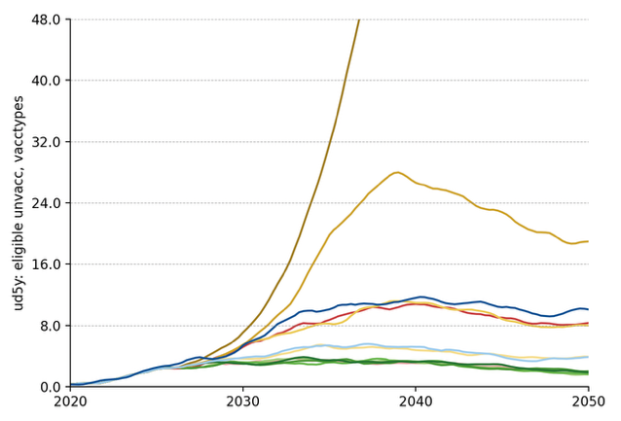

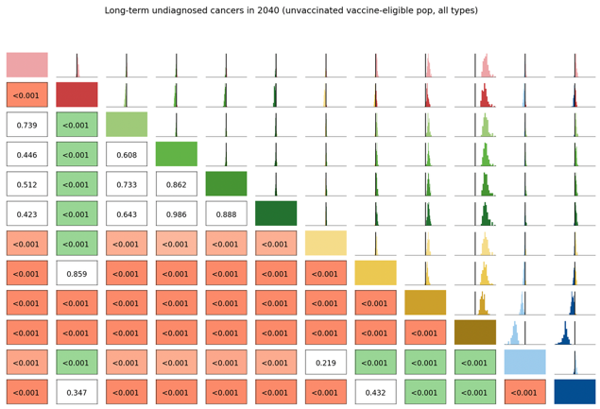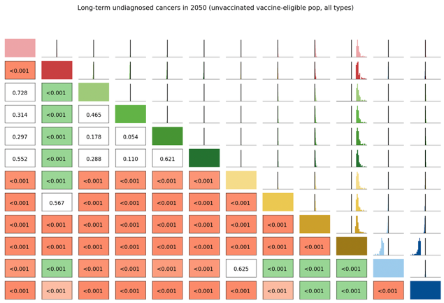

Number of Routine Screens
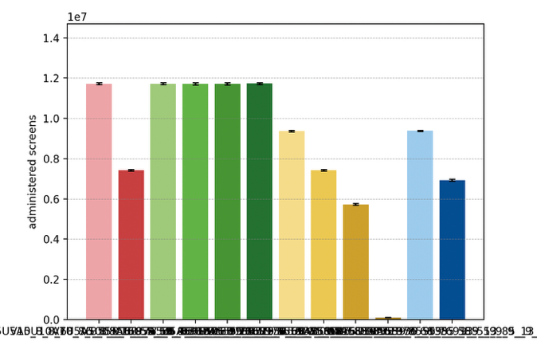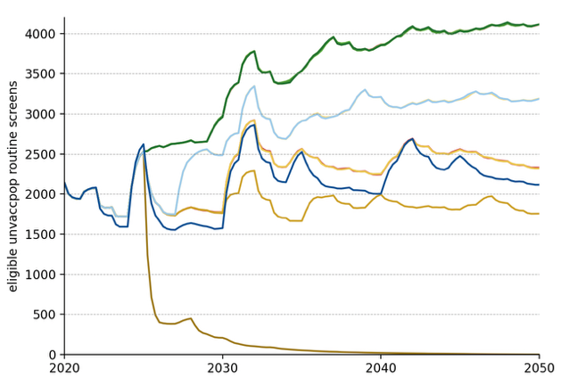

Average Number of Screens per Diagnosed Cancer, 2030-50
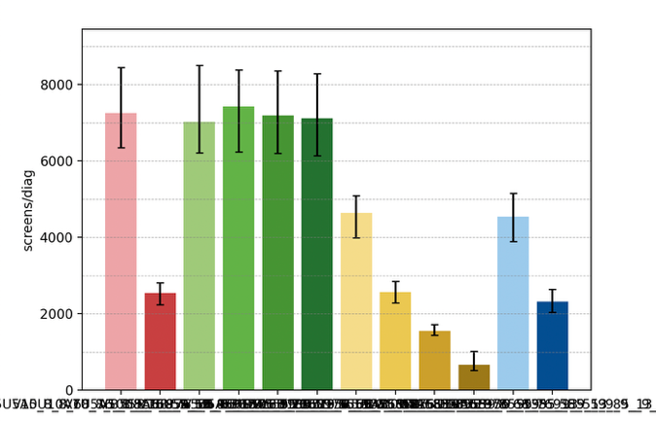

Elimination Probability Table
alg | Elimination Year: Median [LQ, UQ] (_8) | 2040.25 Elimination Probability (_8) | 2050.25 Elimination Probability (_8)
V5U5A5 | 2036 [2033, 2039] | 0.812 | 0.943
V7U5A5 | 2036 [2033, 2038] | 0.861 | 0.935
V10U5A5 | 2036 [2034, 2038] | 0.820 | 0.960
V15U5A5 | 2036 [2034, 2040] | 0.746 | 0.927
V_U5A5 | 2036 [2033, 2039] | 0.804 | 0.927
V7U7A5 | 2040 [2037, 2043] | 0.492 | 0.878
V10U10A5 | 2046 [2044, 2051] | 0.065 | 0.713
V15U15A5 | 2053 [2051, 2055] | 0.016 | 0.246
V_U_A5 | 2056 [2056, 2056] | 0.016 | 0.016
V10U7A5 | 2040 [2038, 2043] | 0.492 | 0.894
V15U10A5 | 2048 [2045, 2052] | 0.040 | 0.574
V10U10A10 | 2047 [2044, 2052] | 0.040 | 0.664
Maximum margin: 0.08876875480445989

